Tutorial
Github

Open the git bash terminal as mentioned below
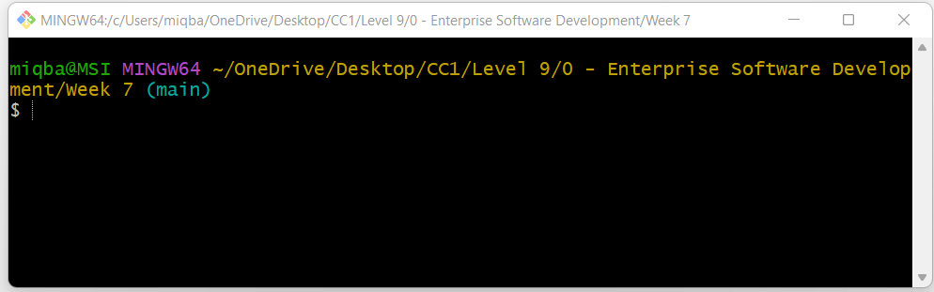

$git config --global user.email "you@example.com"
$git config --global user.name "Your Name"

For example:
$git config --global user.name "MuhammadIqbal2023"

First Create a repository in your github account using the name “ESD”.

Start git bash on your systems and use the following commands to push the files on your local system to github repository
echo "# ESD" >> README.md

munaw@LAPTOP-O8VG0EAQ MINGW64 ~/Desktop/git (main)
$ cd js

munaw@LAPTOP-O8VG0EAQ MINGW64 ~/Desktop/git/js (main)
$ git init

munaw@LAPTOP-O8VG0EAQ MINGW64 ~/Desktop/git/js (main)
$ git add script.js

munaw@LAPTOP-O8VG0EAQ MINGW64 ~/Desktop/git/js (main)
$ git commit -m "Commit script.js"

munaw@LAPTOP-O8VG0EAQ MINGW64 ~/Desktop/git/js (main)
$ git branch -M main

munaw@LAPTOP-O8VG0EAQ MINGW64 ~/Desktop/git/js (main)
$ git remote add "script.js" https://github.com/MuhammadIqbal2023/ESD.git

munaw@LAPTOP-O8VG0EAQ MINGW64 ~/Desktop/git/js (main)
$ git push -u origin main
Enumerating objects: 3, done.
Counting objects: 100% (3/3), done.
Delta compression using up to 8 threads
Compressing objects: 100% (2/2), done.
Writing objects: 100% (3/3), 275 bytes | 275.00 KiB/s, done.
Total 3 (delta 0), reused 0 (delta 0), pack-reused 0
To https://github.com/MuhammadIqbal2021/ESD.git
* [new branch] main -> main
Branch 'main' set up to track remote branch 'main' from 'origin'.

munaw@LAPTOP-O8VG0EAQ MINGW64 ~/Desktop/git/js (main)
$ git status
On branch main
Your branch is up to date with 'origin/main'.

nothing to commit, working tree clean

How to create the branches

Create a branch named as feature_1 on github

munaw@LAPTOP-O8VG0EAQ MINGW64 ~/Desktop/git/js (main)
$ git remote -v
origin https://github.com/MuhammadIqbal2023/ESD.git (fetch)
origin https://github.com/MuhammadIqbal2023/ESD.git (push)
script.js https://github.com/MuhammadIqbal2023/ESD.git (fetch)
script.js https://github.com/MuhammadIqbal2023/ESD.git (push)

munaw@LAPTOP-O8VG0EAQ MINGW64 ~/Desktop/git/js (main)
$ git branch
* main

munaw@LAPTOP-O8VG0EAQ MINGW64 ~/Desktop/git/js (main)
$ git fetch script.js
From https://github.com/MuhammadIqbal2023/ESD
* [new branch] feature_1 -> script.js/feature_1
* [new branch] main -> script.js/main

munaw@LAPTOP-O8VG0EAQ MINGW64 ~/Desktop/git/js (main)
$ git branch
* main

munaw@LAPTOP-O8VG0EAQ MINGW64 ~/Desktop/git/js (main)
$ git checkout feature_1
Switched to a new branch 'feature_1'
Branch 'feature_1' set up to track remote branch 'feature_1' from 'script.js'.

munaw@LAPTOP-O8VG0EAQ MINGW64 ~/Desktop/git/js (feature_1)
$ git branch
* feature_1
main

Open the file using the nano editor

$ git checkout feature_1
Switched to branch 'feature_1'
Your branch is up to date with 'script.js/feature_1'.

munaw@LAPTOP-O8VG0EAQ MINGW64 ~/Desktop/git/js (feature_1)
$ nano script.js

Changed the variable name from ‘c’ to ‘d’

munaw@LAPTOP-O8VG0EAQ MINGW64 ~/Desktop/git/js (feature_1)
$ git commit -am "changed the name of the variable in the feature_1 branch"
[feature_1 474a336] changed the name of the variable in the feature_1 branch
1 file changed, 1 insertion(+), 1 deletion(-)

munaw@LAPTOP-O8VG0EAQ MINGW64 ~/Desktop/git/js (feature_1)
$ git push -u origin feature_1
Enumerating objects: 5, done.
Counting objects: 100% (5/5), done.
Delta compression using up to 8 threads
Compressing objects: 100% (2/2), done.
Writing objects: 100% (3/3), 330 bytes | 330.00 KiB/s, done.
Total 3 (delta 0), reused 0 (delta 0), pack-reused 0
To https://github.com/MuhammadIqbal2023/ESD.git
567197e..474a336 feature_1 -> feature_1
Branch 'feature_1' set up to track remote branch 'feature_1' from 'origin'.

munaw@LAPTOP-O8VG0EAQ MINGW64 ~/Desktop/git/js (feature_1)
$ nano script.js

munaw@LAPTOP-O8VG0EAQ MINGW64 ~/Desktop/git/js (main)
$ git merge feature_1
Merge made by the 'recursive' strategy.

munaw@LAPTOP-O8VG0EAQ MINGW64 ~/Desktop/git/js (feature_1)
$ git checkout main
Switched to branch 'main'
M script.js
Your branch is ahead of 'origin/main' by 2 commits.
(use "git push" to publish your local commits)

munaw@LAPTOP-O8VG0EAQ MINGW64 ~/Desktop/git/js (feature_1)
$ git commit -am "changed the name of the variable in the feature_1 branch to ee"
[feature_1 45a712f] changed the name of the variable in the feature_1 branch to ee
1 file changed, 1 insertion(+), 1 deletion(-)

munaw@LAPTOP-O8VG0EAQ MINGW64 ~/Desktop/git/js (feature_1)
$ git push -u origin feature_1
Enumerating objects: 5, done.
Counting objects: 100% (5/5), done.
Delta compression using up to 8 threads
Compressing objects: 100% (2/2), done.
Writing objects: 100% (3/3), 337 bytes | 337.00 KiB/s, done.
Total 3 (delta 0), reused 0 (delta 0), pack-reused 0
To https://github.com/MuhammadIqbal2023/ESD.git
474a336..45a712f feature_1 -> feature_1
Branch 'feature_1' set up to track remote branch 'feature_1' from 'origin'.

munaw@LAPTOP-O8VG0EAQ MINGW64 ~/Desktop/git/js (main)
$ nano script.js

munaw@LAPTOP-O8VG0EAQ MINGW64 ~/Desktop/git/js (main)
$ git commit -am "changed the name of the variable in the main branch to ff"
[main 0cc210e] changed the name of the variable in the main branch to ff
1 file changed, 1 insertion(+), 1 deletion(-)

munaw@LAPTOP-O8VG0EAQ MINGW64 ~/Desktop/git/js (main)
$ git push -u origin main
Enumerating objects: 6, done.
Counting objects: 100% (6/6), done.
Delta compression using up to 8 threads
Compressing objects: 100% (3/3), done.
Writing objects: 100% (4/4), 529 bytes | 529.00 KiB/s, done.
Total 4 (delta 0), reused 0 (delta 0), pack-reused 0
To https://github.com/MuhammadIqbal2023/ESD.git
4f400d4..0cc210e main -> main
Branch 'main' set up to track remote branch 'main' from 'origin'.

*************** Merging and Conflict***************
munaw@LAPTOP-O8VG0EAQ MINGW64 ~/Desktop/git/js (main)
$ git merge feature_1
Auto-merging script.js
CONFLICT (content): Merge conflict in script.js
Automatic merge failed; fix conflicts and then commit the result.

Open the file
munaw@LAPTOP-O8VG0EAQ MINGW64 ~/Desktop/git/js (main|MERGING)
$ nano script.js

<<<<<<< HEAD
const ff = 50;
=======
const ee = 50;
>>>>>>> feature_1

const b = () => {
console.log('Hi there');
};

Delete the line which you do not need.

const ee = 50;

const b = () => {
console.log('Hi there');
};

munaw@LAPTOP-O8VG0EAQ MINGW64 ~/Desktop/git/js (main|MERGING)
$ nano script.js

munaw@LAPTOP-O8VG0EAQ MINGW64 ~/Desktop/git/js (main|MERGING)
$ git add .

munaw@LAPTOP-O8VG0EAQ MINGW64 ~/Desktop/git/js (main|MERGING)
$ git commit

A vi editor will be opened. Clost the editor by typing :q! and hit the Enter key

[main c75f01e] Merge branch 'feature_1'

Conflict is resolved

munaw@LAPTOP-O8VG0EAQ MINGW64 ~/Desktop/git/js (main)
$ git push -u origin main
Enumerating objects: 1, done.
Counting objects: 100% (1/1), done.
Writing objects: 100% (1/1), 232 bytes | 232.00 KiB/s, done.
Total 1 (delta 0), reused 0 (delta 0), pack-reused 0
To https://github.com/MuhammadIqbal2023/ESD.git
0cc210e..c75f01e main -> main
Branch 'main' set up to track remote branch 'main' from 'origin'.

munaw@LAPTOP-O8VG0EAQ MINGW64 ~/Desktop/git/js (main)
$ git status
On branch main
Your branch is up to date with 'origin/main'.

nothing to commit, working tree clean

Tasks:
Create a repository STPS on Github and Load the folder for Sales Transaction Processing System (STPS) on Github.
Perform the operations for Merge for Main branch and sub-branches.

